**RMIT International University Vietnam**

**Assignment 1 – Static Website**

|  |  |
| --- | --- |
| **Subject Code:** | COSC2430 |
| **Subject Name:** | Web Programming |
| **Location & Campus (SGS or HN) where you study:** | HN campus |
| **Student name:** | Nguyen Nghia Hiep |
| **Student Number:** | s3978270 |
| **Teachers Name:** | Dr. Ushik Shrestha Khwakhali, Tom Huynh |
| **Assignment due date:** | 12th August |
| **Date of Submission:** | 12th August |
| **Number of pages including this one:** | 10 |
| **Word Count:** |  |

I declare that in submitting all work for this assessment I have read, understood, and agree to the content and expectations of the Assessment Declaration.

I have completed the SCD consent form and it applies here.

# Introduction

1. **Introduction to Sanctuary**

Sanctuary is a book retailing website. Sanctuary was born from a deep-seated love for literature and storytelling. Sanctuary aims to create an environment for fellow book lovers and voracious book readers to gather and explore the many different written works. The website includes various features with three different categories for reader to explore the library of books that is being put on the market.

The scope of this website is to create a platform that is primarily functionality to ensure customers can operate on the website. Secondarily the user experience and user interface aspects to provide to customers the greatest satisfaction when using Sanctuary. The objective of Sanctuary is to demonstrate that the frontend for this website can be created using what we have learnt in HTML and CSS.

1. **Scope:**

|  |  |  |  |
| --- | --- | --- | --- |
| **In project** | **Priority** | **Features** | **Description** |
|  | | |
| High | Responsive Website | * It is the highest priority to create a website that is highly functional on all platforms to for a larger audience size. |
| Navigation Bar | * It is important to create a navigation bar for users to traverse the website. * Creating a horizontal navigation bar for higher resolution devices and a vertical navigation bar for smaller screens. |
| Linking Page | * Linking between webpages and having suitable links to create a multi-page website. |
| Themes | * The webpage should be pleasing to the eye, should follow a certain themes and styling. * This is the highest priority because it should make the website stand out among the crowd. |
|  | | |
| Mid | Effects | * Adding animations and CSS effects to improve the user interface and the aesthetic of the website. * Special effects will make |
|  |  |
|  |  |
|  |  |
|  |  |
|  | | |
| Low | Loading Page | * The page that shows up while loading between webpage. |
| Hover on Image Animation |  |
|  |  | | |
| **Out of scope** | Beyond Limitation | Zoom In on Image | * Hovering on the image will create a zoom in picture. * Due to the limited time of this assignment and the current ability, this feature was beyond the limitation. |
|  |  |

# Project Description

1. **Features Description**
   * Responsive navigation bar: A horizontal navigation bar is not entirely responsive in smaller screens. A vertical bar was used for smaller resolutions, using a checkbox idea to make the vertical bar visible and not visible when checked, creating a burger-menu navigation bar.
   * Animated card hover effect: Display a small box when we hover on an image. This design was implemented using the hover selector and visibility property to create an effect with a link that can be clicked on to navigate to that book detail website.
   * Text blur effects: Provide visual cue when hovering on links. Create a blurred effect when the cursor is hovering on a link.
   * Loading page: A loading page in between of webpages. Inspired by [1] Coding Artist 2018, the effect replaces the instant webpage change which is abrupt, this effect will showcase a glass of water filling up when loading to a new webpage.
   * Extra section: Added subscribe input box at the footer of the website. This improves the aesthetic of the website.
   * Colorful Icons: Icons that will change colors when the cursor hovers on it. When the cursor hovers on the icons at the footer, a different color will be presented to show that we can click on these icons.
2. **Lesson Learnt**

From this assignment I have understand how to use HTML and CSS more effectively. For HTML, I have seen significant improvements to my website structuring. Although it is not complete perfect, the assignment has given me insights on how an actual webpage would organize with many links for multi-pages and different structures for each type of webpages.

The most important skill that I have learnt in this assignment is undoubtedly programming styling using CSS. While learning in lectures CSS is a language that came across as being very confusing and difficult to me, it felt as if you must do so much for changing a box format. However, when doing this assignment not only was I able to polish my CSS programming by having to solve many styling issues. I have also learnt a lot by looking at many different inspirations on different social media platform and looking at other programmers impressive styling.

The deadline was extremely close to me given the 4 weeks duration of the project. This because of my improper time organization as well as perfectionism. I had to redo the website a couple of times because the color schemes were not to my standards. In the end this backfired on me, many ideas must be scrapped due to time constraints. From this I have learnt to better organize my time and continue to learn and build my web programming arsenal.

# Implementation Details

* + **Design Ideas**

When approaching Sanctuary, I wanted to create a heavenly like appeal, Sanctuary aims to re-create an environment of reading a book where it is set in a comfortable and relaxing manner. According to verywellmind 2022, blue is associated with the feeling of calmness and relaxation. Health News 2023 also highlight that looking at the sky will increase mental health and relaxation.

Therefore, the design aspects of Sanctuary attempt to replicate the colors of the sky. Which has the main palette of white and light blue.

* + **Home Page**

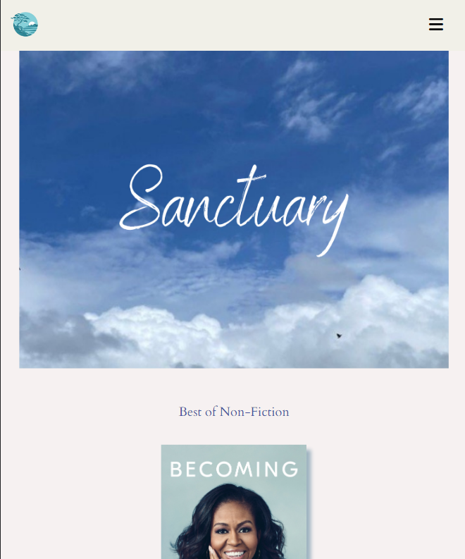

Figure 1: Home Page

The above image is the overview of the home page in mobile and tablet screen sizes around 991px and below. From the Figure 1, there display a burger-menu which was implemented using a checkbox input; when the checkbox is in a checked state the <nav> element visibility property will convert from hidden to visible displaying a vertical navigation bar. For larger screen sizes a normal flexbox row system is used to create a horizontal navigation bar (Figure 2). The position was also set to fixed, so the navigation bar will always follow us as we are looking at the webpage.



Figure 2: Navigation Bar (> 991px)

Moving on to achieve three books for each category as stated in the requirements, I used a flexbox system using a combination of flex-directions: row and column and multiple <div> elements to achieve the desired outcome (Figure 3).

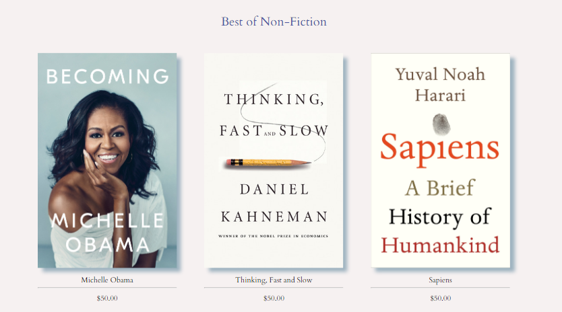

Figure 3: Category Box

This effect was repeated 3 times to achieve the three categories on the home page (Best of Non-Fiction, Best of Fiction and Best of Children Books). These links can be clicked on to navigate to the subcategory section.



Figure 4: Footer

The footer of the website consists of a smaller navigation bar that was also achieve using <a> tags and flexbox like the above navigation bar. The footer also contains a follow us section using icons from Font Awesome 2023. The icons when hovered will change colors.

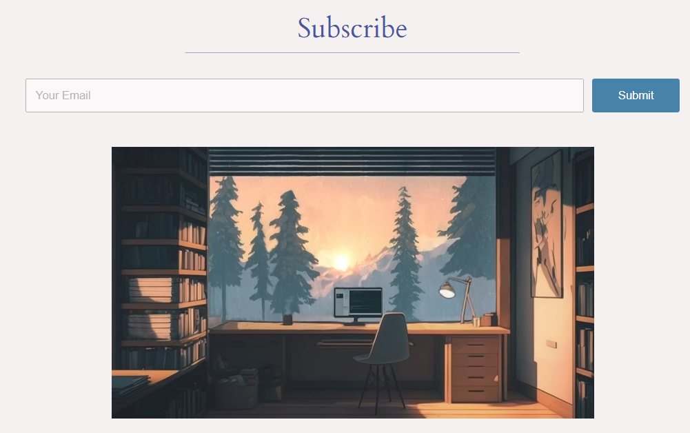

Figure 5: Added Elements

In the home page a rich media was added set to autoplay using the embedded Youtube share function, and I added a input box using <label> and <input> to create an aesthetic subscribe box.

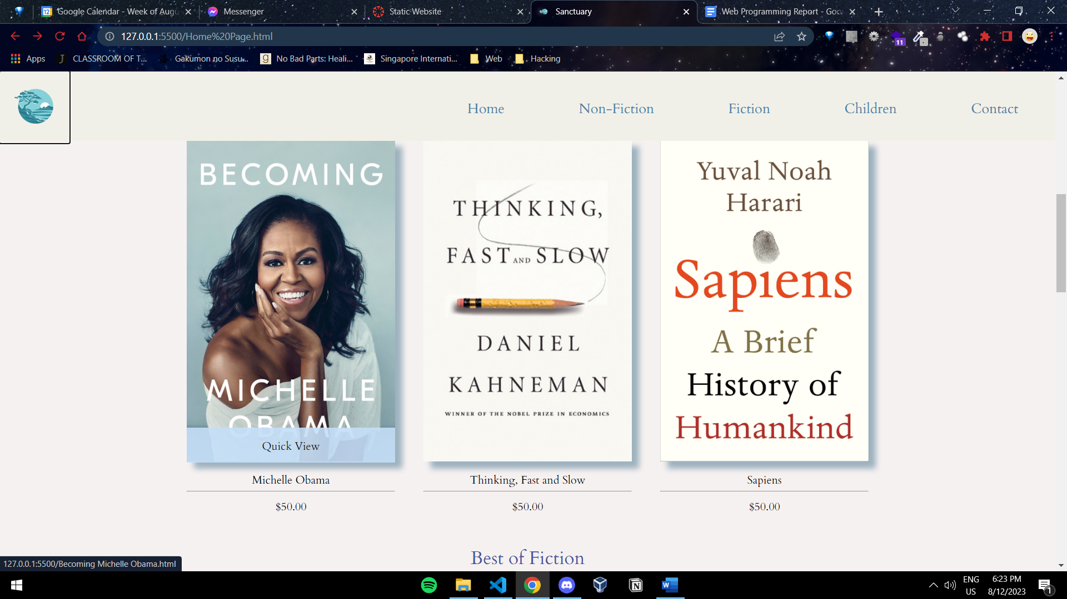

Figure 6: Hover Animation on Image

I also added a hovering effect for each image (Figure 6), to add to the minimalistic appeal and improve on the website user interface. This idea I took inspiration from Haveri ka Krishna 2021.

* + **Subcategory**



Figure 7: Loading Page

When using the website, the user may notice that Sanctuary uses an in-between loading page. Coding Artist 2018, inspired the creation of this animation, the idea of the animation is to create a cup using CSS and we will use @keyframes to change the image of the water to move up the cup. After this we will use a <meta> tag to link to the target website. All links will link to this loading page.

The subcategory page is like the home page, however, instead of 3 books there is 4 books on each row, the effect was also achieved using flexbox.

* + Contact Page
  + Book Detail Page
  + Bugs

The website is not entirely perfect there contain some bugs. One bug particularly is the animation when hovering on the image (Figure 8). When programming this animation as we hover on an image in the same flexbox row the animation will appear for that image. However, as we change the flex-direction to column the box is outplace. The same applies to different screen sizes. To improve on this, for mobile and tablet screen sizes the animation visibility was set to none, however, the bug still exists in larger screen sizes. The animation is operational in my native laptop resolution (1536 x 722)

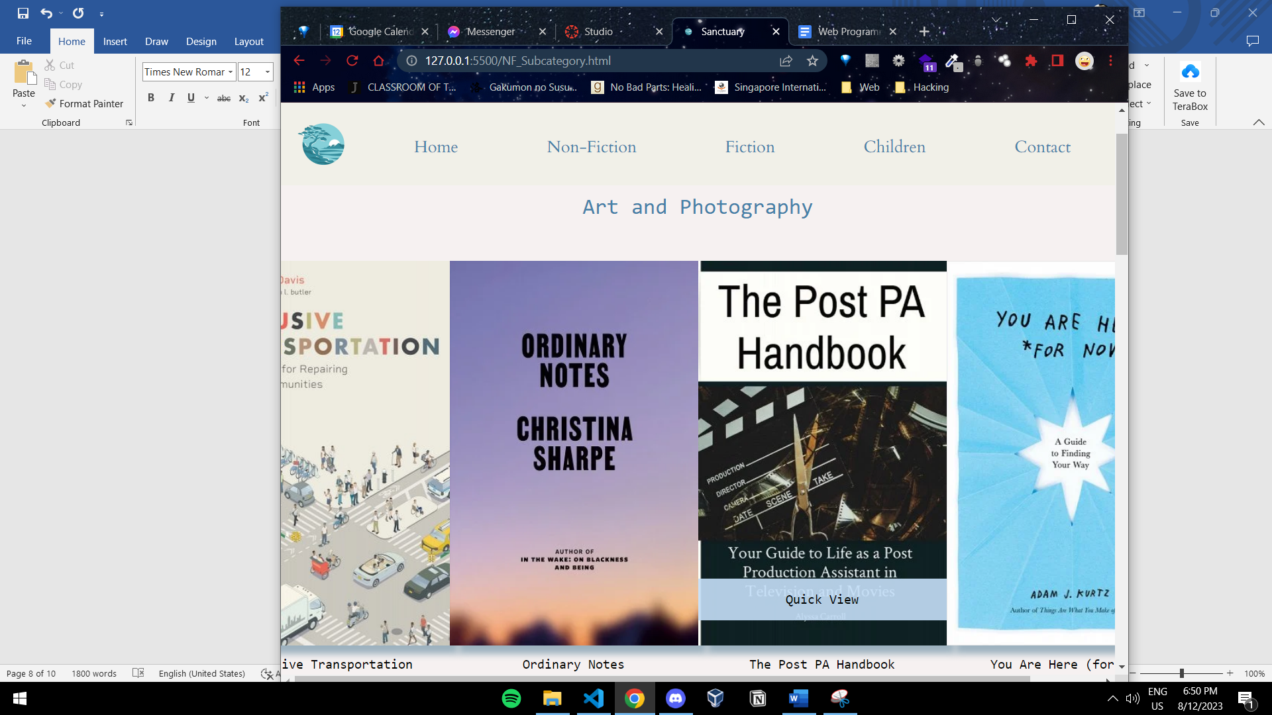

Figure 8: Hovering Image Bug

* + Visual Aid

The website is user friendly, since simplicity and minimalism was the theme of this website, however, there is a link that will demonstrate the website in use.

<https://rmit-arc.instructuremedia.com/embed/b1faca51-741c-4042-a998-da2581a62237>

# Conclusion

The website overall is constructed like what I had envisioned, however, due to time constraints many ideas were scrapped and is not completed yet. Although the it has met the requirements for the assignment, this project has potential to grow more. The project still contains bugs and flaws. The webpage responsiveness is not entirely up to standard for larger screen sizes. The font display is still too small. The website also lacks accessibility options for more niche groups. The page also lacks SEO impact, which is ill for future marketing and grabbing user attention.

Moving pass this project, I intend to continue to build and fix this website to make it fully functional. Learning more from Web Programming course as well as other sources; JavaScript, back-end languages can be implemented into the website. The implementation of these programming languages will enable the website to do much more, more functional, more aesthetic and serve a good customer experience. Beyond that, security measures for the website can be added to protect users’ information and generate profit.

# V. References

[1] Coding Artist, “Coffee Filling Cup-Animated CSS Loader.,” *YouTube*. Aug. 18, 2018. Accessed: Aug. 11, 2023. [YouTube Video]. Available: <https://www.youtube.com/watch?v=TzjRcwKuXQs&t=9s>

[2]

Font Awesome, “Font Awesome,” *Fontawesome.com*, 2023. (accessed Aug. 12, 2023). <https://fontawesome.com/>

[3]

“Bookshop: Buy books online. Support local bookstores.,” *Bookshop*, 2023. (accessed Aug. 12, 2023). <https://bookshop.org/>

[4]

Haveri ka Krishna, “Animated Card Hover Effect | Html & CSS | CodeEra,” *YouTube*. Mar. 01, 2021. Accessed: Aug. 12, 2023. [YouTube Video]. Available: <https://www.youtube.com/watch?v=t5zFfDdvApE>

[5]

“Browse Fonts - Google Fonts,” *Google Fonts*, 2023. Aug. 12, 2023. <https://fonts.google.com/>

[6]

“Books & Publishers Website Templates | Online Store | Wix.com,” *Wix.com*, 2020. (accessed Aug. 12, 2023) <https://www.wix.com/website/templates/html/online-store/books-publishers>

[7]

Better World Books, “Buy New & Used Books Online with Free Shipping | Better World Books,” *Better World Books*, 2023. (accessed Aug. 12, 2023. <https://www.betterworldbooks.com/>

[8]

Verywellmind, “How the Color Blue Impacts Moods, Feelings, and Behaviors,” *Verywell Mind*, 2022. Accessed 12th August 2023 <https://www.verywellmind.com/the-color-psychology-of-blue-2795815>

[9]

“Skychology: What Is It and Does It Really Work? | HealthNews,” *HealthNews*, Jan. 25, 2023. Accessed 12th August 2023, <https://healthnews.com/mental-health/self-care-and-therapy/skychology-what-is-it-and-does-it-really-work/>

‌

‌

‌